**Project Planning Phase**

**Project Planning Template (Product Backlog, Sprint Planning, Stories, Story points)**

|  |  |
| --- | --- |
| Date | 28th June 2025 |
| Team ID | LTVIP2025TMID49754 |
| Project Name | FlightFInder |
| Maximum Marks | 5 Marks |

**Product Backlog, Sprint Schedule, and Estimation (4 Marks)**

Use the below template to create product backlog and sprint schedule

| **Sprint** | **Functional Requirement (Epic)** | **User Story Number** | **User Story / Task** | **Story Points** | **Priority** | **Team Members** |
| --- | --- | --- | --- | --- | --- | --- |
| Sprint-1 | User Authentication | USN-1 | As a user, I can register for the platform by entering my name, email, password, and confirming password. | 2 | High |  |
| Sprint-1 | User Authentication | USN-2 | As a user, I receive a confirmation email after registering. | 1 | High |  |
| Sprint-2 | User Authentication (OAuth) | USN-3 | As a user, I can register/login using Google OAuth. | 2 | Medium |  |
| Sprint-1 | Login | USN-4 | As a user, I can log into the platform using my email and password. | 1 | Medium |  |
| Sprint-1 | Flight Dashboard | USN-5 | As a user, I can view available flights filtered by source, destination, and date. | 3 | High |  |
| Sprint-2 | Flight Dashboard | USN-6 | As a user, I can view my booking history and upcoming trips. | 2 | Medium |  |
| Sprint-3 | Flight Search + Booking | USN-7 | As a user, I can search for flights and select a seat before booking. | 2 | High |  |
| Sprint-3 | Cart | USN-8 | As a user, I can add a flight to my cart and update passenger details before checkout. | 2 | High |  |
| Sprint-3 | Checkout | USN- 9 | As a user, I can securely checkout and receive a booking confirmation email. | 3 | High |  |

**Project Tracker, Velocity & Burndown Chart: (4 Marks)**

| **Sprint** | **Total Story Points** | **Duration** | **Sprint Start Date** | **Sprint End Date (Planned)** | **Story Points Completed (as on Planned End Date)** | **Sprint Release Date (Actual)** |
| --- | --- | --- | --- | --- | --- | --- |
| Sprint-1 | 20 | 6 Days | 24 Apr 2025 | 29 Apr 2025 | 20 | 29 Apr 2025 |
| Sprint-2 | 20 | 6 Days | 31 Apr 2025 | 05 May 2025 | 20 | 05 May 2025 |
| Sprint-3 | 20 | 6 Days | 07 May 2025 | 12 May 2025 | 20 | 12 May 2025 |
| Sprint-4 | 20 | 6 Days | 14 May 2025 | 19 May 2025 | 20 | 19 May 2025 |
|  |  |  |  |  |  |  |
|  |  |  |  |  |  |  |
|  |  |  |  |  |  |  |
|  |  |  |  |  |  |  |

**Velocity:**

Imagine we have a 10-day sprint duration, and the velocity of the team is 20 (points per sprint). Let’s calculate the team’s average velocity (AV) per iteration unit (story points per day)

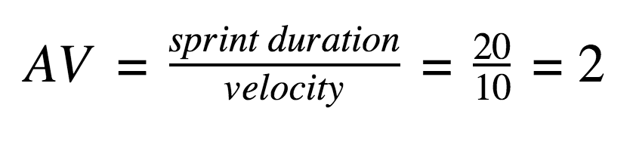

**Burndown Chart:**

A burn down chart is a graphical representation of work left to do versus time. It is often used in agile[software development](https://www.visual-paradigm.com/scrum/what-is-agile-software-development/) methodologies such as [Scrum](https://www.visual-paradigm.com/scrum/scrum-in-3-minutes/). However, burn down charts can be applied to any project containing measurable progress over time.

[**https://www.visual-paradigm.com/scrum/scrum-burndown-chart/**](https://www.visual-paradigm.com/scrum/scrum-burndown-chart/)

[**https://www.atlassian.com/agile/tutorials/burndown-charts**](https://www.atlassian.com/agile/tutorials/burndown-charts)

**Reference:**

[**https://www.atlassian.com/agile/project-management**](https://www.atlassian.com/agile/project-management)

[**https://www.atlassian.com/agile/tutorials/how-to-do-scrum-with-jira-software**](https://www.atlassian.com/agile/tutorials/how-to-do-scrum-with-jira-software)

[**https://www.atlassian.com/agile/tutorials/epics**](https://www.atlassian.com/agile/tutorials/epics)

[**https://www.atlassian.com/agile/tutorials/sprints**](https://www.atlassian.com/agile/tutorials/sprints)

[**https://www.atlassian.com/agile/project-management/estimation**](https://www.atlassian.com/agile/project-management/estimation)

[**https://www.atlassian.com/agile/tutorials/burndown-charts**](https://www.atlassian.com/agile/tutorials/burndown-charts)